**Build Output**: [Integration of Sonarqube with Jenkins]

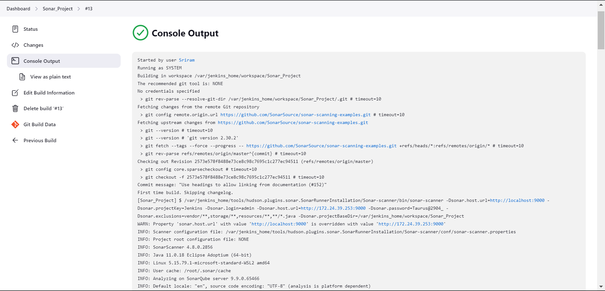

**Git repo**: <https://github.com/SonarSource/sonar-scanning-examples.git>

**Sonar.properties file:**

sonar.projectKey=Jenkins

sonar.login=admin

sonar.password=admin

#sonar.sources=/var/jenkins_home/workspace/Sonar_Project/productcatalogue

sonar.host.url=http://172.24.39.253:9000

#sonar.exclusions=stockmanager/**,productcatalogue/**,shopfront/**,**/*.java

sonar.exclusions=vendor/**,storage/**,resources/**,**/*.java

**Sonarqube Analysis report and Quality Gate Status:**

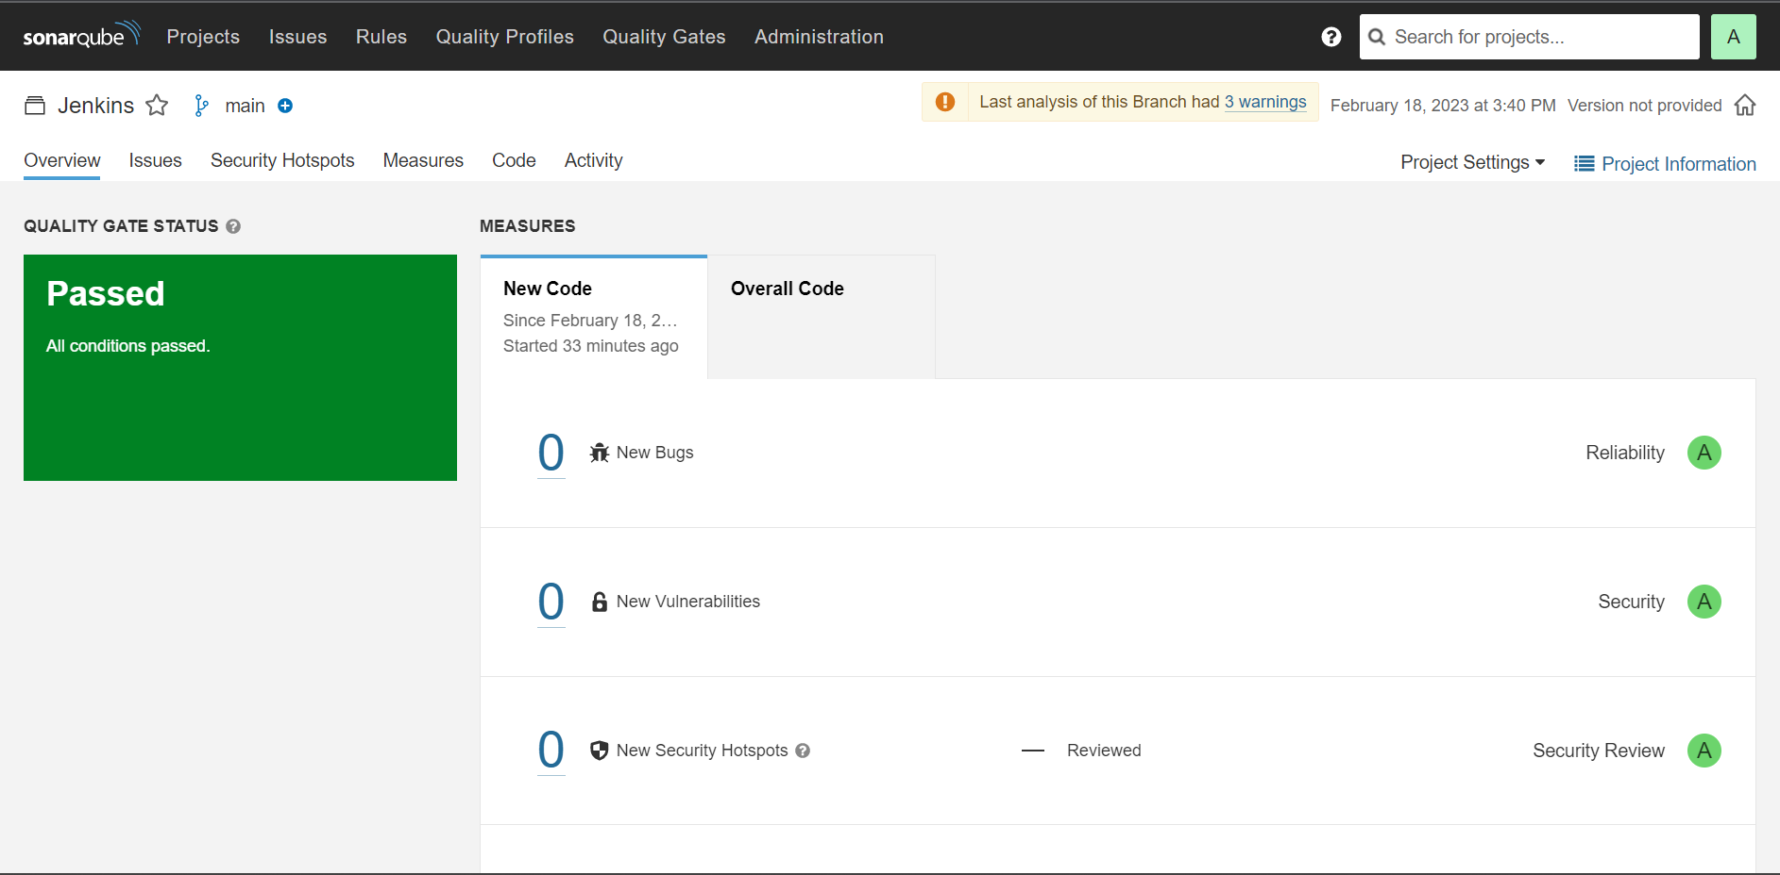

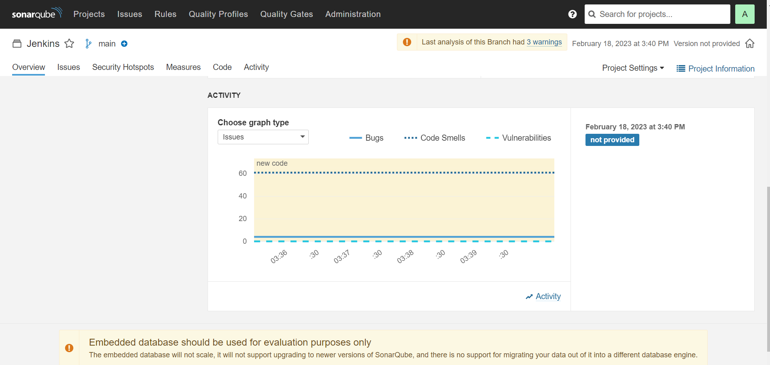

**DOCKER INTEGRATION**

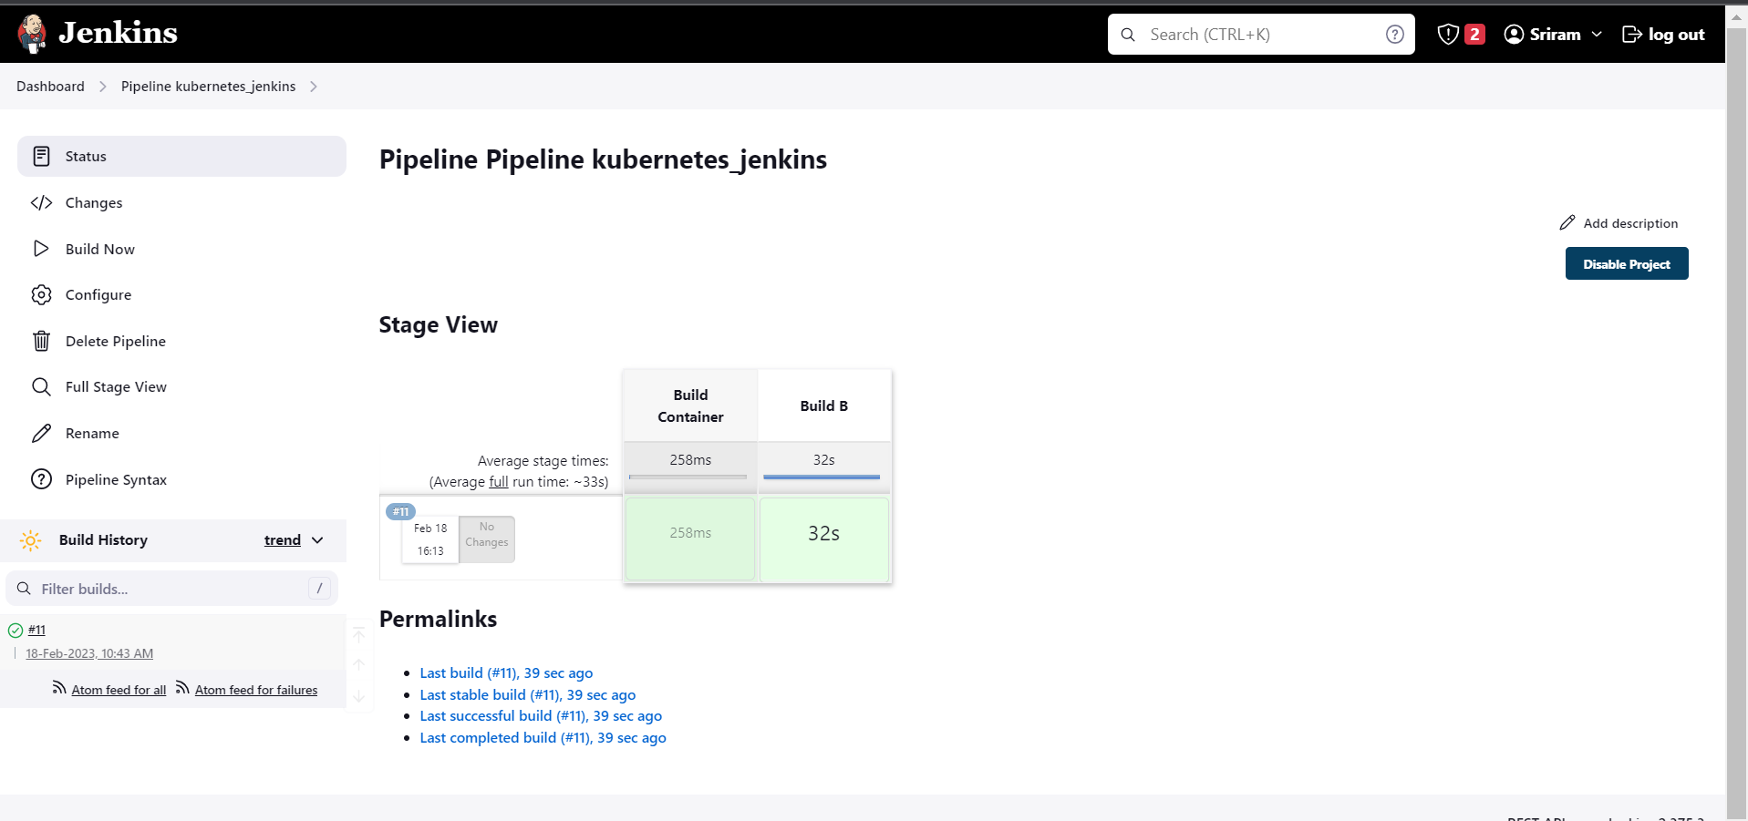

**Jenkins File[Declarative pipeline] for Docker integration and job automation:**

**pipeline {**

**environment {**

**dockerimagename = "praveensingam1994/nodeapp"**

**dockerImage = ""**

**}**

**agent any**

**stages {**

**stage('Checkout Source') {**

**steps {**

**git 'https://github.com/praveen1994dec/kubernetes_Jenkins_deployment.git'**

**}**

**}**

**stage('Build Container') {**

**steps {**

**echo 'Building Container..'**

**script {**

**def dockerHome = tool 'MyDocker'**

**env.PATH = "${dockerHome}/bin:${env.PATH}"**

**}**

**}**

**}**

**stage('Build image') {**

**steps{**

**script {**

**dockerImage = docker.build ${dockerimagename}**

**}**

**}**

**}**

**stage('Build B') {**

**steps {**

**build job: "Sonar_Project", wait: true**

**}**

**}**

**stage('Pushing Image') {**

**environment {**

**registryCredential = 'dockerhubcred'**

**}**

**steps{**

**script {**

**docker.withRegistry( 'https://registry.hub.docker.com', registryCredential ) {**

**dockerImage.push("${env.BUILD_NUMBER}")**

**dockerImage.push("latest")**

**}**

**}**

**}**

**}**

**stage('Deploying App to Kubernetes') {**

**steps {**

**script {**

**kubernetesDeploy(configs: "deploymentservice.yml", kubeconfigId: "kubernetes")**

**}**

**}**

**}**

**}**

**}**